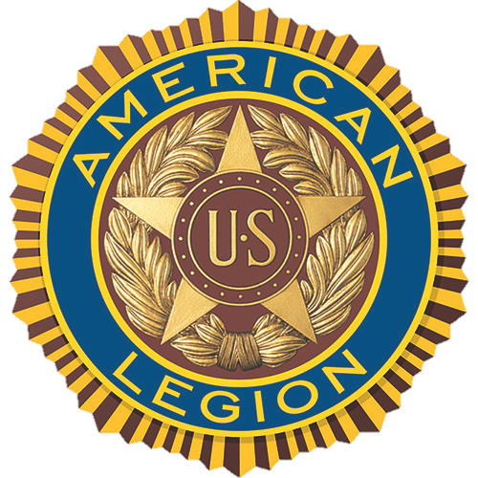

American Legion invites veterans to share VA experiences
at (CITY, STATE) town hall meeting

FOR IMMEDIATE RELEASE

The American Legion, the nation’s largest and most influential veterans service organization, invites all (CITY) area veterans and their family members to a town hall meeting to discuss their VA care.

The meeting will be held at (TIME) (DAY), (MONTH/DATE), at (LOCATION) (STREET ADDRESS, CITY, STATE)

The town hall is one of many such events that the Legion will conduct around the United States this year. The Legion hosts these events to hear feedback from veterans about the quality of health care they receive at their local VA facilities.

Representatives from The American Legion Department of (STATE), The American Legion National Headquarters office in Washington, D.C., and representatives from VA and members of the (STATE) congressional delegation will be in attendance.

Contacts:
(LEGION HQ STAFF CONTACT), (PHONE NUMBER), (E-MAIL)
(LOCAL VA CONTACT), (PHONE NUMBER), (E-MAIL)

About The American Legion
With a current membership of over 2 million wartime veterans, The American Legion was founded in 1919 on the four pillars of a strong national security, veterans affairs, Americanism, and youth programs. Legionnaires work for the betterment of their communities through more than 13,000 posts across the nation.

