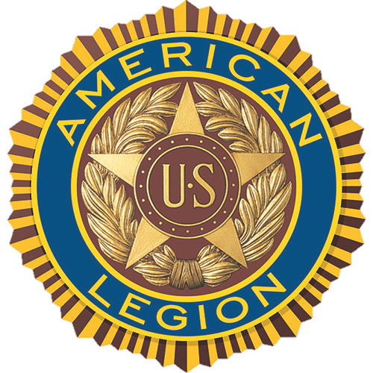

MEDIA ADVISORY

American Legion invites veterans to share VA experiences
at (CITY, STATE) town hall meeting

WHO | The American Legion Department of (STATE)
WHAT | The American Legion invites local media to cover the town hall meeting at (LOCATION) where veterans from around the area will share their experiences with the VA medical center. See contact information below to arrange coverage
WHEN | (TIME) (DAY), (MONTH/DATE)
WHERE | (LOCATION) (STREET ADDRESS, CITY, STATE)
WHY | The town hall event is one of about 12 such events that the Legion will conduct around the United States this year. The Legion hosts these events to hear feedback from veterans about the quality of health care they receive at their local VA facilities.
HOW | Representatives from The American Legion Department of (STATE), The American Legion National Headquarters office in Washington, D.C., and representatives from VA and members of the (STATE) congressional delegation will listen as veterans share their VA care experience.

Contacts:
(LEGION HQ STAFF CONTACT), (PHONE NUMBER), (E-MAIL)
(LOCAL VA CONTACT), (PHONE NUMBER), (E-MAIL)

